



Use Case Diagram
Simply Rugby System
After additional documentation from a client, I created a new document which concentrates only on the requirement provided by the SimplyRugby chairman.
System will be our rugby application.
Actors is someone or something that uses our system to achieve a goal or complete specific task. Actors are external objects and need to be placed outside the system.
Use case describe what our system does. Represents an action that accomplishes some sort of task within system.
Relationship we can divide into four points :
- Association relationship and its basic communication or interaction.
- Include show dependency between a base use and an included use case. every time base use case is executed, the included use case is executed as well or base use case required an included use case in order to be complete.
- Extend will only happen if certain criteria are met, its like extend behaviour of our use case like if we make mistake in log in process then show error massage.
- Generalization relationship also knows as inheritance. We can have generalization of use case but also actors can have it.
Lets define our four elements :
- System
Simply rugby application system
- Actors
Coach
- Use Cases
Login
Login Validation
Failed Login Attempt
View assigned team
Select team
View Players
Edit Player Skills
Save Player Skills
View All Coaches
Exit

- Relationship
Coach is related to:
Login
Login Validation
Failed Login Attempt
View assigned team
Select team
View Players
Edit Player Skills
Save Player Skills
View All Coaches
Exit
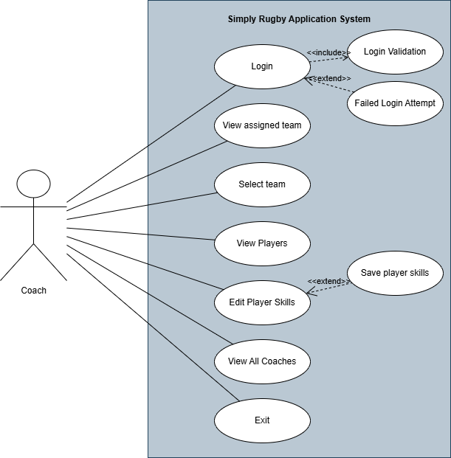

Summary
The UML Use Case Diagram was created to graphically represent user interactions with the system. Additionally, it helps in planning, analysing, and developing software.
Below, an example of a user interaction is provided.
Use Case ID: | 01
Use Case Name: | Login
Created by: | Kamil Milej
Date Created: | 13/05/2025
Actors: | Coach
Trigger: | The coach tries to log in by entering their username and password.
Pre-conditions: | The coach must be registered in the Simply Rugby System.
Post-conditions: | Success State: The coach is logged in and authenticated.  Failure State: The coach fails to log in due to invalid credentials.
Normal Flow: | - The coach enters the username and password.  - The coach clicks the "Log In" button.  - The system validates the entered data (includes Validate Login).  - If the username or password is incorrect, the system shows an error message (extends Failed Login Attempt).  - If the username and password are valid, the system grants access to the main interface.  - The user can perform further actions.
Extends (Alternative flows): | Failed Login Attempt
Includes: | Validate login

Use Case ID: | 02
Use Case Name: | Edit Player Skills
Created by: | Kamil Milej
Date Created: | 13/05/2025
Actors: | Coach
Trigger: | Coach selects a player from the assigned team and chooses to edit their skill levels.
Pre-conditions: | The coach must be logged in  The coach must have access to at least one team with players
Post-conditions: | Success: Skill levels are updated in memory and displayed in the UI.  Failure: No change is saved until the coach explicitly clicks "Save Skills".
Normal Flow: | - Coach logs in and navigates to “My Team”  - Coach selects a team and a player from the list.  - The player's skill levels are displayed in a table  - Coach edits skill levels using dropdowns  - Changes are shown immediately in the UI but not persisted  - Coach can now choose to save if want by press save button (exclude Save Player Skills)  - Exit, before application will end ask to save all changes
Extends (Alternative flows): | Save Player Skills
Includes: | -

